**7.10 Permission Key Check**

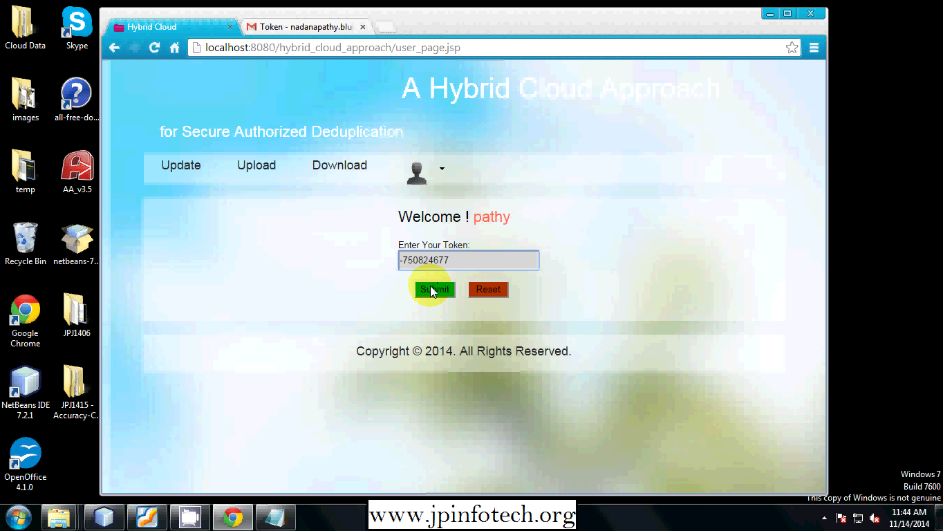

7.11 Permission Key Check

**7.12 User All Permissions View**

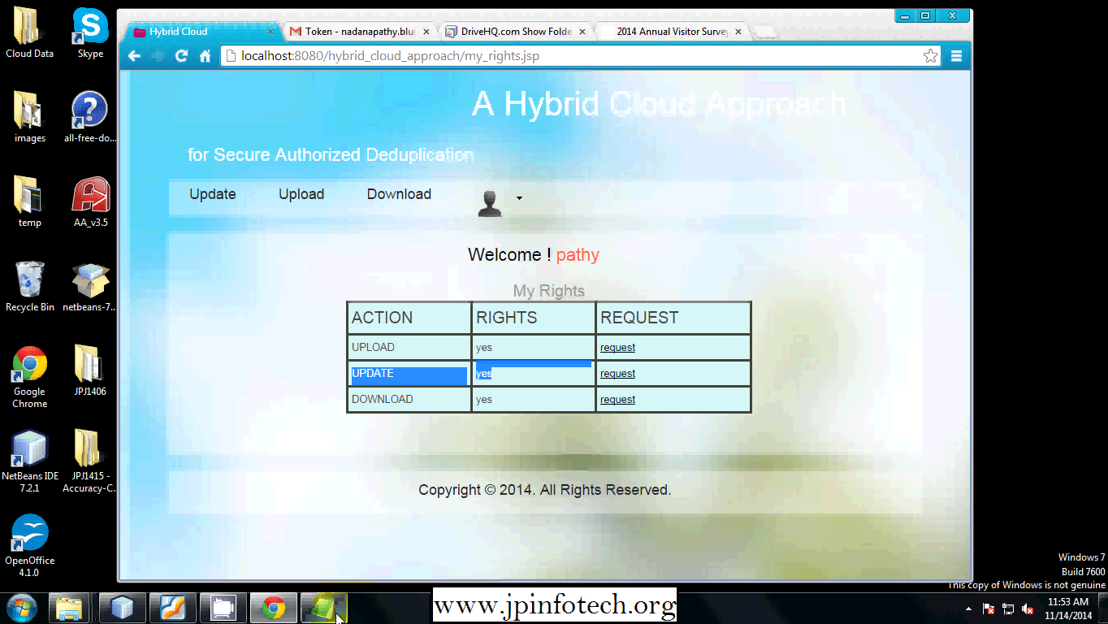

7.12 Users All Permission View